Arthur Williams III
Actor (Non-union)
LinkedIn/pub/arthur-williams;Twitter.com/@ArthurBos7;facebook.com/Unofficial.Arthur

arthur.wllms@gmail.com WT/HT Tel: 617-249-4104
Model Club Inc. 5’8”/160

Film/Movies/Documentaries:
Dragon’s of Kandahar MacArthur (Lead) David J. Curtis Prod./Dir. David J. Curtis
Free Will Mike (Lead) ADR Saturn Visions Prod./Dir. Richard LeClerc
Fate In The Balance Paul Jennings (Principle) Northern Lights Prod.
Impact Opponents Coach (Principle) BFA Productions/Dir. Michael O’Connor
Sella’s Kitchen Pierre/Napo (Lead) Moving Filmz/Dir.Ralph Celesin Detroit Club Patron/Man in Motel Annapurna Pictures/Dir.Kathryn Bigelow
Curveball (webseries) Officer Frank Lindsey (Principle) No traffic Media/Dir.Duron Cotton
Streets Run Red Lazurus King, Forensic Officer (Principle) Ungovernable Films/Dir. Paul M. McAlarney
Undecided Captain Oliver Lawrance (Principle) Flowrenola Productions/Dir. Sherif Bakare
Bleed for This Boxers entourage Verdi Production and Exc. Prod. Martin Scorsese
In Plain View Jackie Rivers (Principle) Microburst Media, Dir. Joseph A. Conforti

Commercials:
Bose Customer (Principle) Element Productions
Bank of America Customer (Principle)

Theatre:
The Watson’s Go to Birmingham Mr. Allums/Mr. Roberts Eastern Nazarene College, Dir. Frankie Bruny
The Bank Attack Amadou/Montique’s Lawyer City Life/Vida Urbana Pro./Dir. A. Ansaldi
Waiting Room (Director) Imagine Acting Pro./Arthur Willaims III
The Magician Richard (Lead) Imagine Acting Prod./Dir.Abigail Lucas

Education/Training:
Acting for film and television Bates Wilder C.P. Casting
Audition Master Class Rosalie Joseph Boston Casting
Tao Zen Acting Michael Messier The Art of Zen and creating the inner greatness
Emerson College Steve Zorkin Acting 101

Singing Voice: Tenor/2nd Tenor

Dialects/Languages: New England American English/Puerto Rican Spanish/British English/Southern American English/Bostonian/Medical Terminology/Haitian American/Orator

Special Skills: Theatre dance/singing/roller skating/ice Skating/scuba diving/snorkeling/water Skiing/Kayaking/weight lifting/ free-Style fighting/ Martial Arts/physical fitness training/basketball/track and field/sprint runner/basic horseback riding.
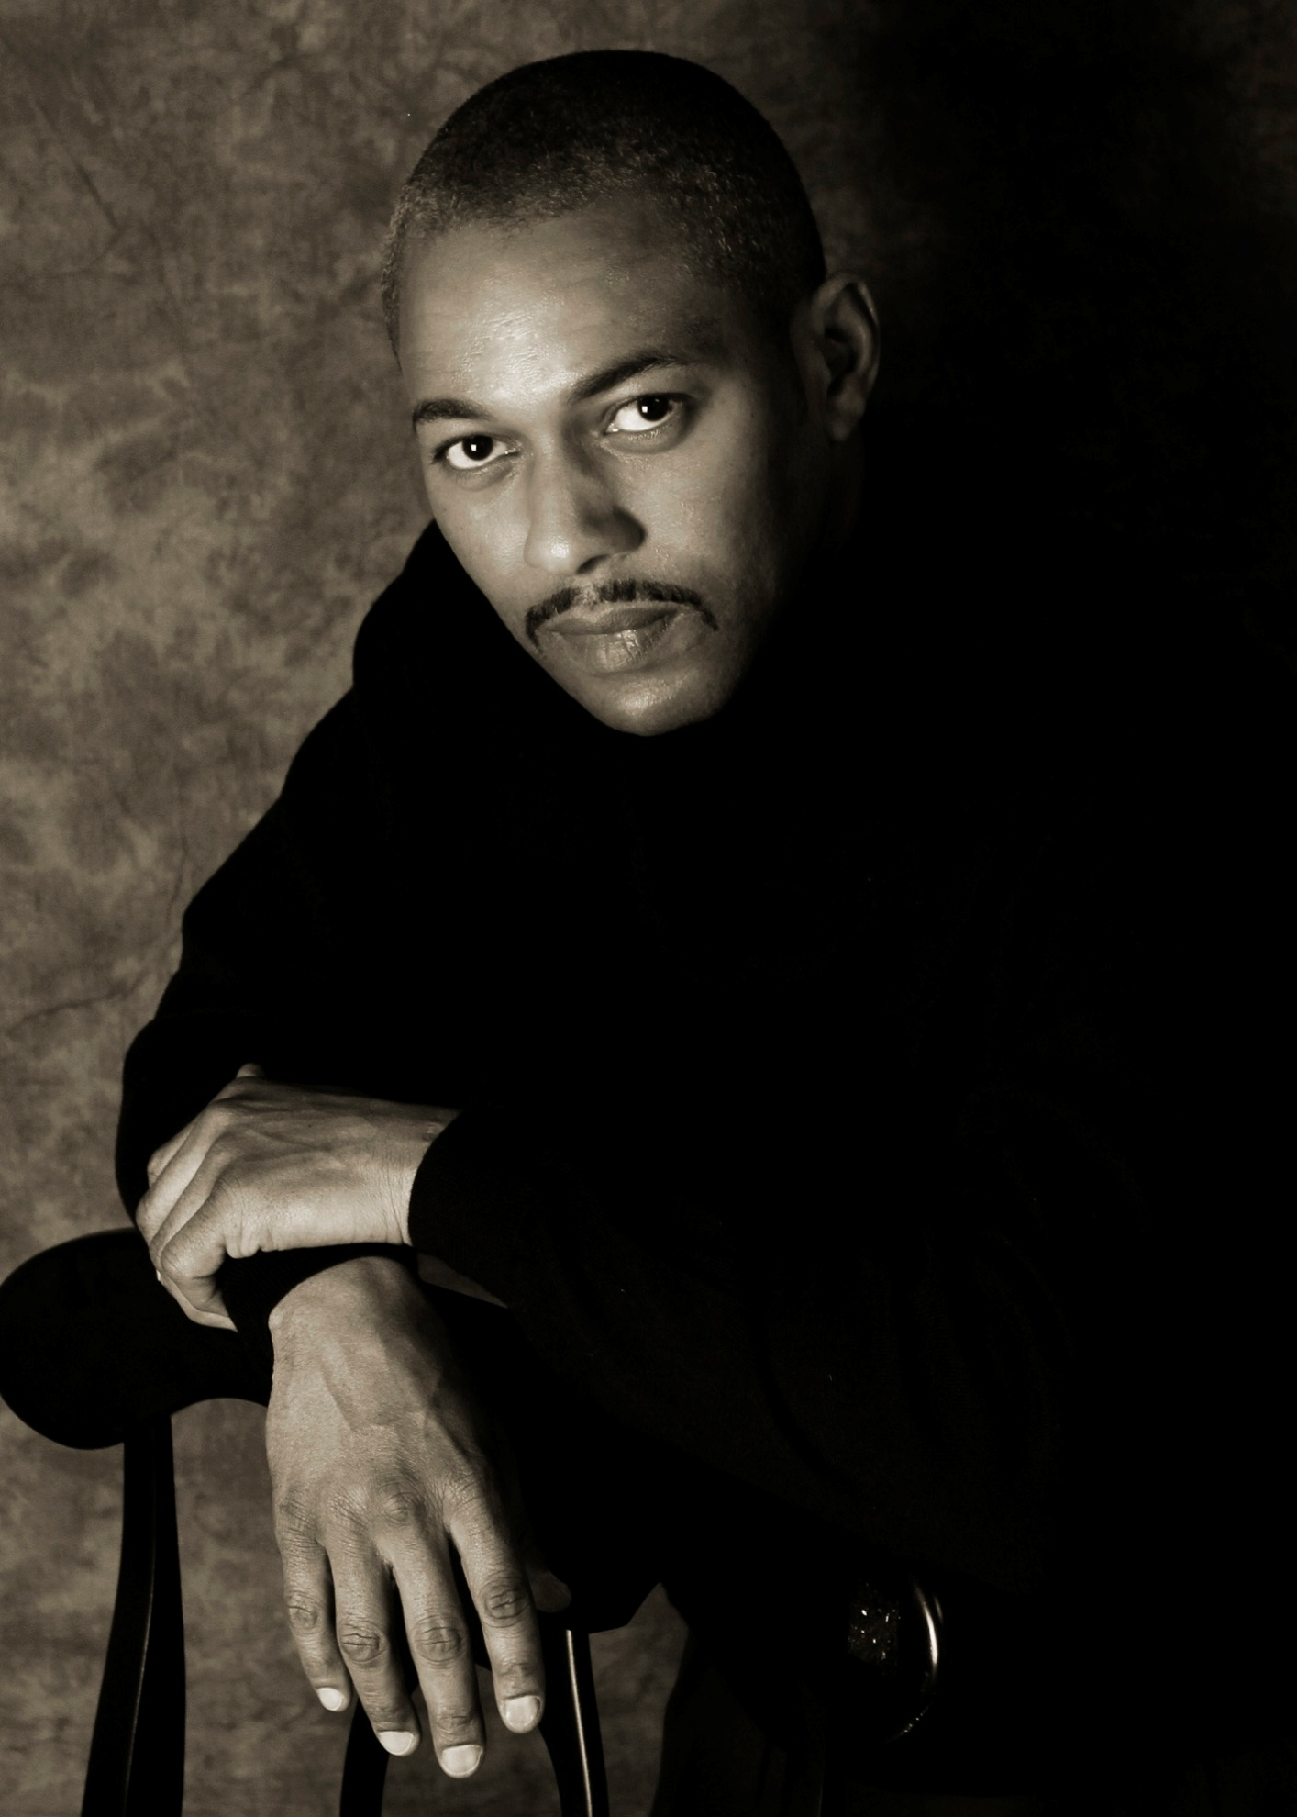
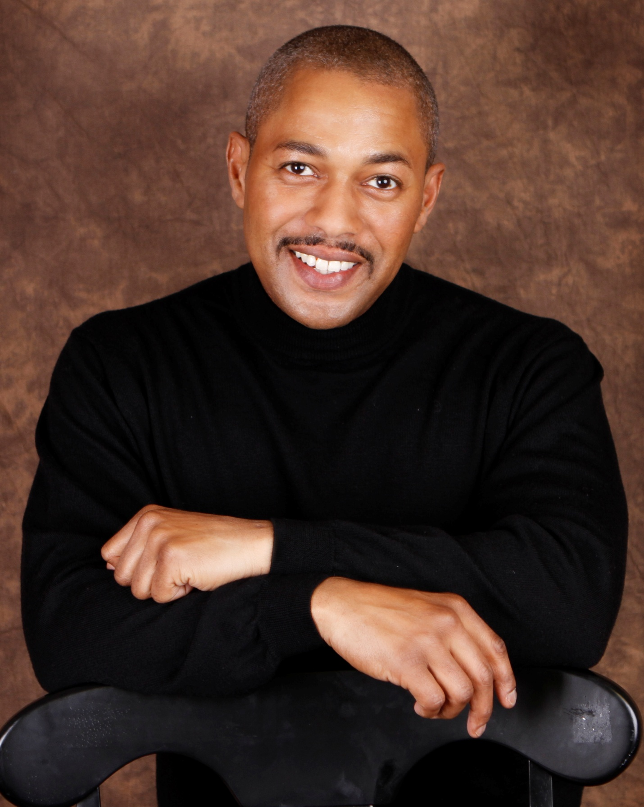
Arthur Williams III/arthur.wllms@gmail.com
Arthur Williams III/arthur.wllms@gmail.com

